Hero | Neo – The Matrix Trilogy  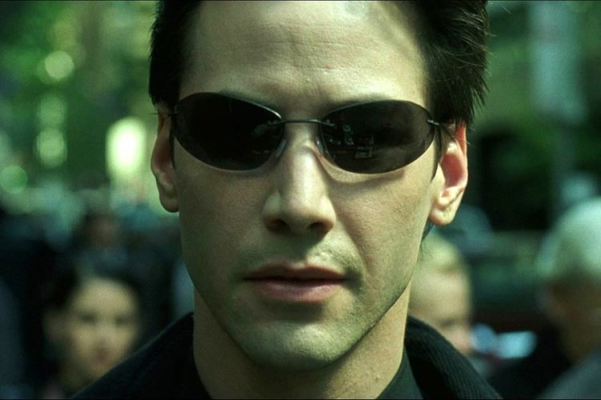 | James Bond – The James Bond Franchise  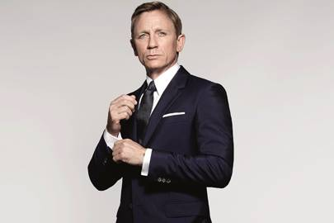 | Ellen Ripley – Alien Franchise  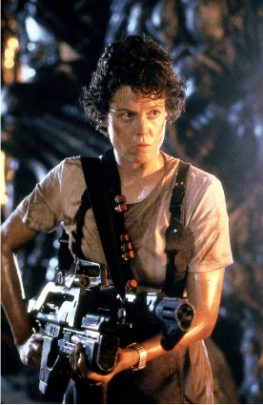
The Wise Old Man or Mentor | Alfred Pennyworth – The Dark Knight Trilogy  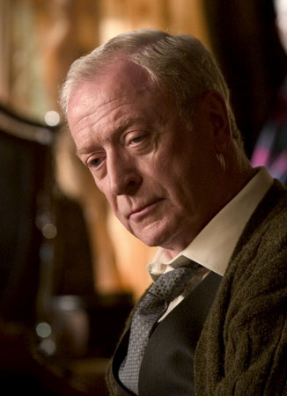 | Dumbledore  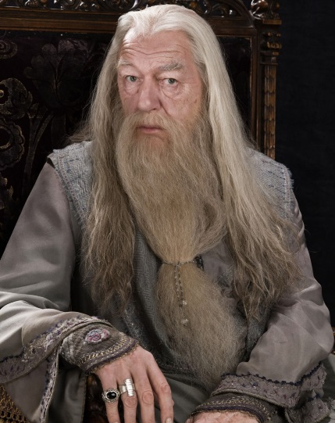 | Mr. Miyagi – The Karate Kid  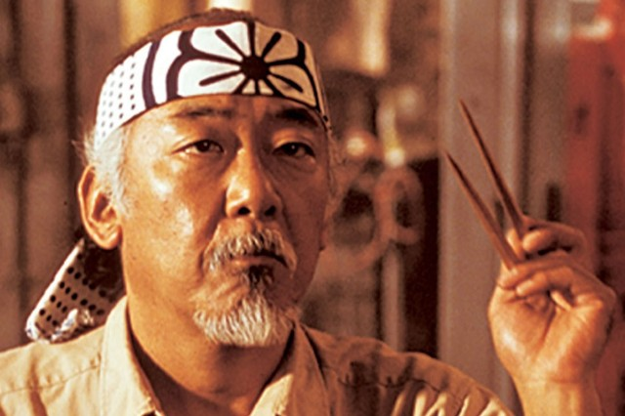
The Threshold Guardian | Fluffy – Harry Potter  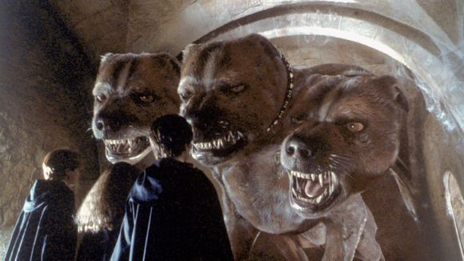 | Wall Guard – Stardust  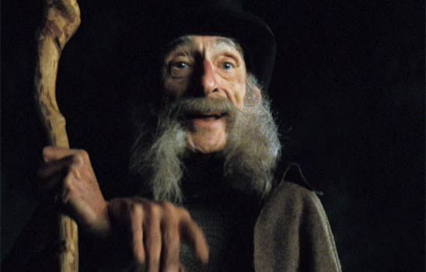 | The Faun – Pan’s Labyrinth  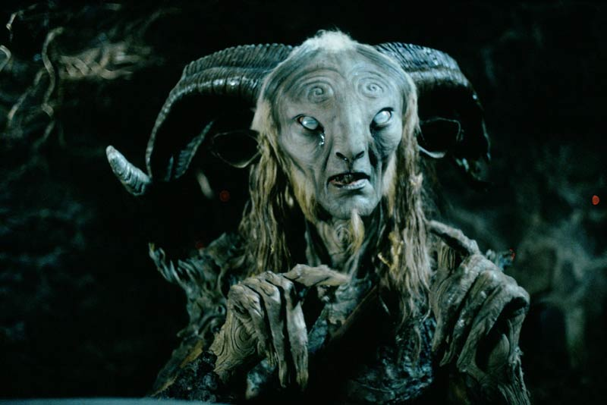
The Herald | R2D2 – Star Wars  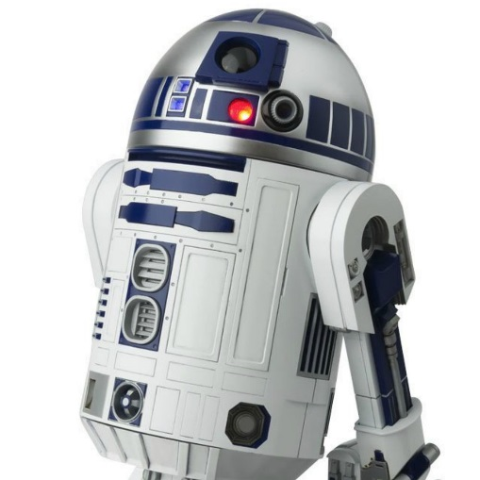 | Effie Trinket – The Hunger Games  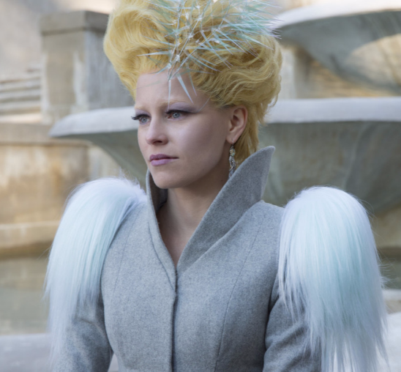 | M – James Bond  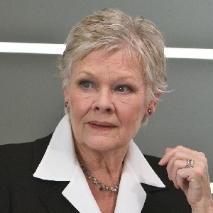
The  Shapeshifter | Anakin Skywalker – Star Wars  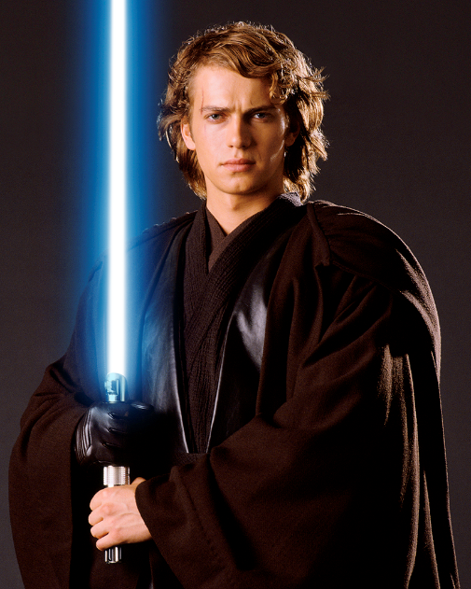 | Harvey Dent/Two Face – The Dark Knight  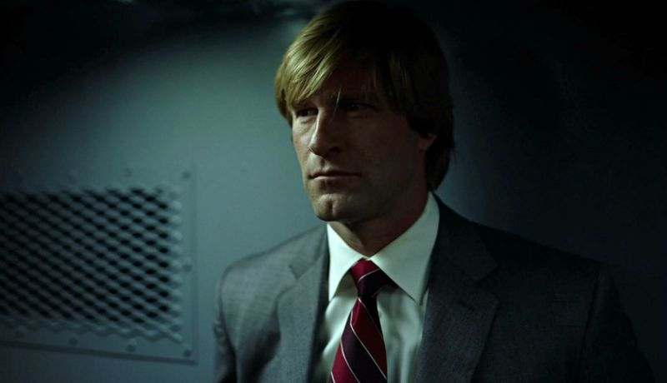 | John Connor – Terminator Genisys  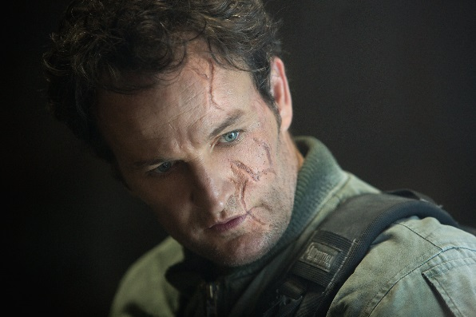
The  Shadow | Darth Vader – Star Wars  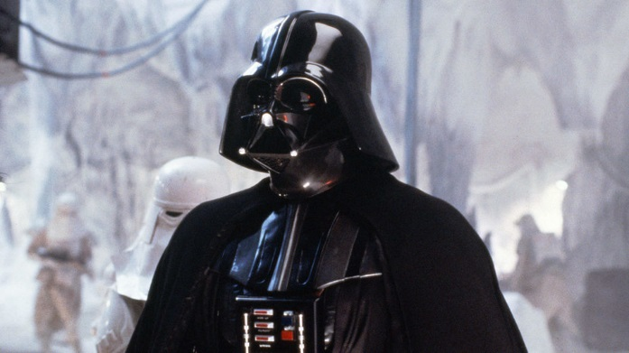 | Loki – The Avengers  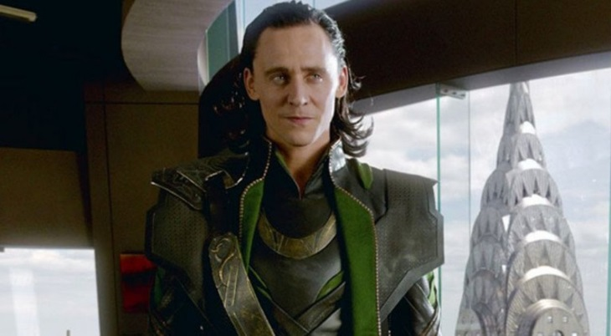 | Raoul Silva – Skyfall  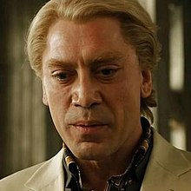
The  Trickster | C3PO – Star Wars  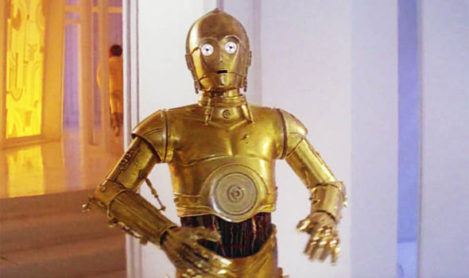 | Jack Sparrow – Pirates of the Caribbean  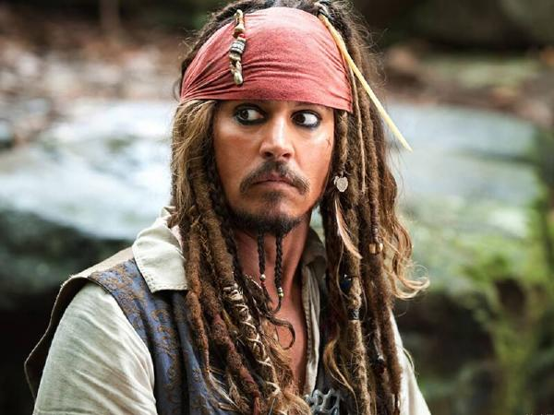 | The Mask – The Mask  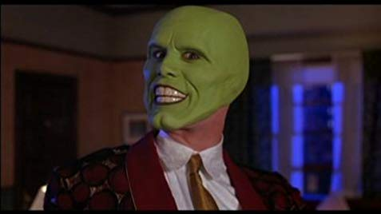
Heroine or  Goddess | Ellen Ripley – Alien Franchise | Wonder Woman – Wonder Woman  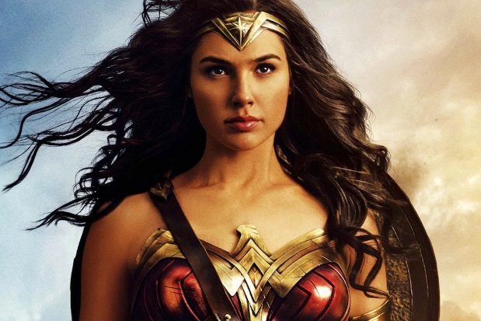 | Lara Croft – Tomb Raider  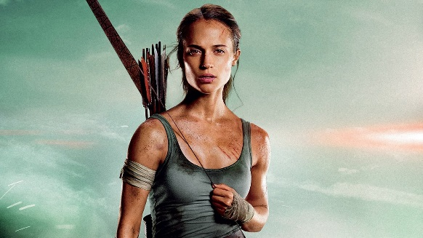
Villain | The Emperor – Star Wars  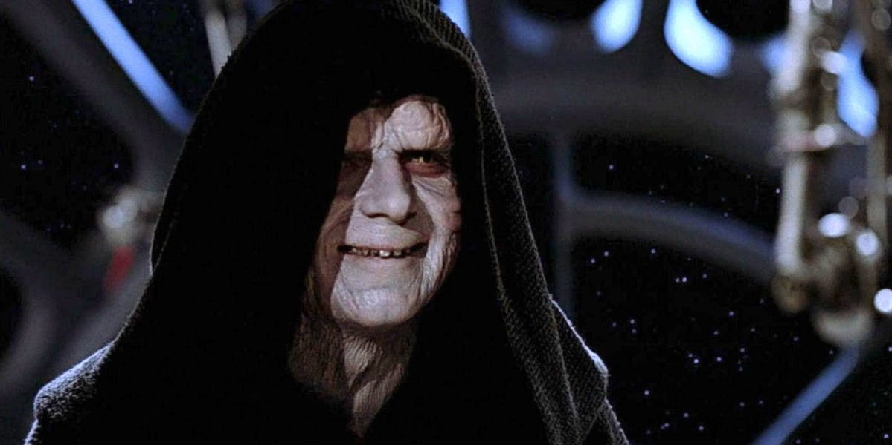 | Agent Smith – The Matrix  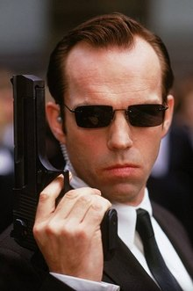 | Hans Gruber – Die Hard  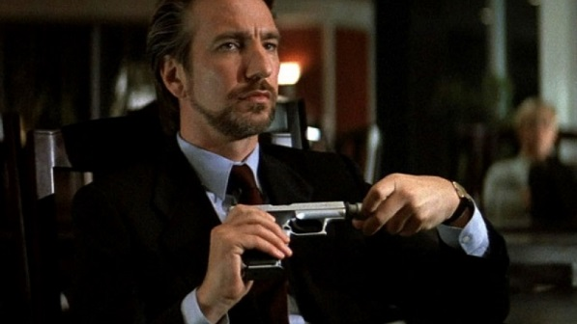
The Sidekick – Helpers | Hermione Granger – Harry Potter  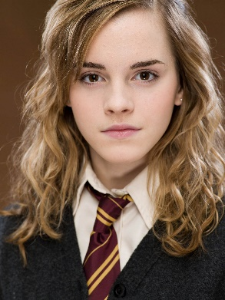 | John Watson – Sherlock Holmes  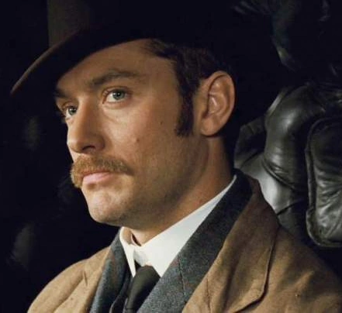 | Chewbacca – Star Wars  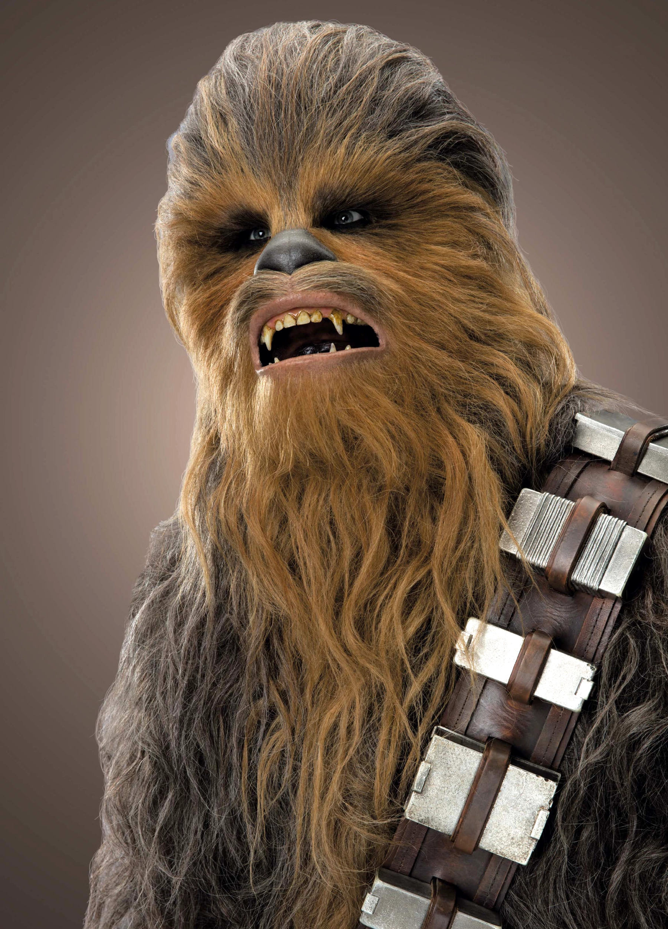
The  Femme Fatale | Jennifer Check – Jennifer’s Body   | Catwoman – Batman Returns  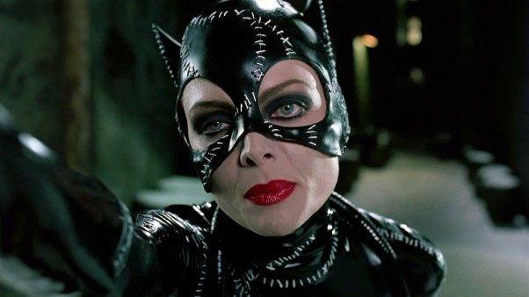 | Jane Smith – Mr and Mrs Smith  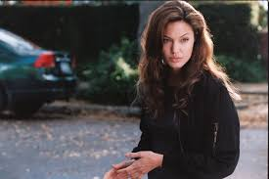
Alchemist | The White Witch – The Chronicles of Narnia  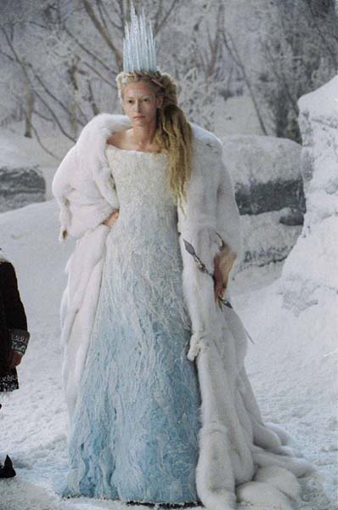 | Gandalf – The Lord of the Rings  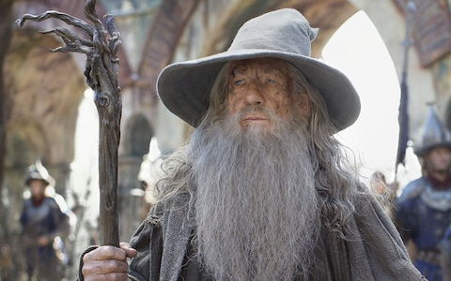 | The Wicked Witch of the West – The Wizard of Oz  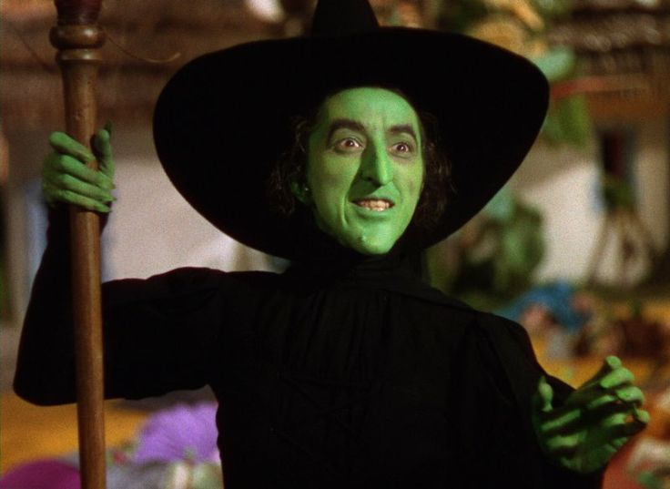
The  Mad Scientist/  Nerd boy | Dr Frankenstein – Frankenstein  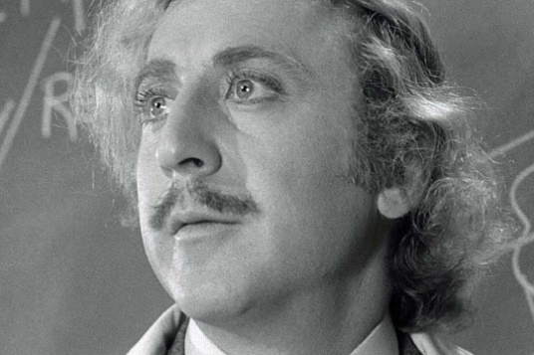 | David Lightman – War Games  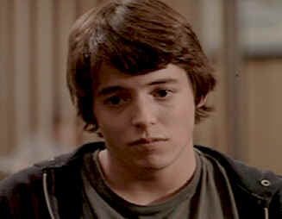 | Lex Luthor – Batman v Superman  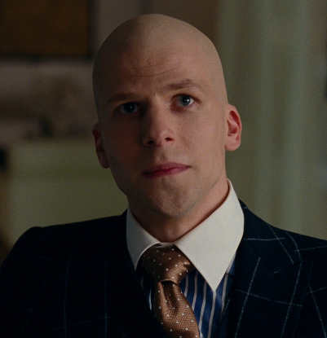
The Nerd Girl | Evie Carnahan – The Mummy  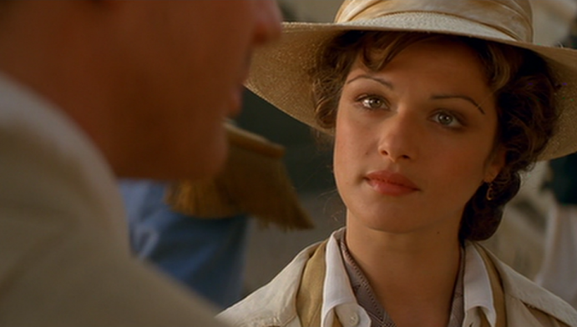 | Hermione Granger – Harry Potter  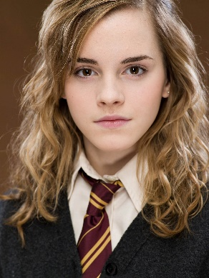 | Carrie – Carrie  
Angel | Bartleby – Dogma  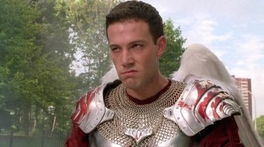 | Clarence – It’s a Wonderful Life  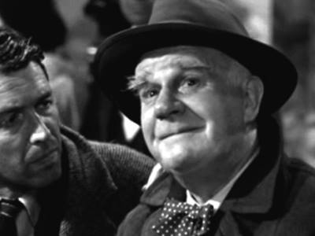 | Damiel – Wings of Desire  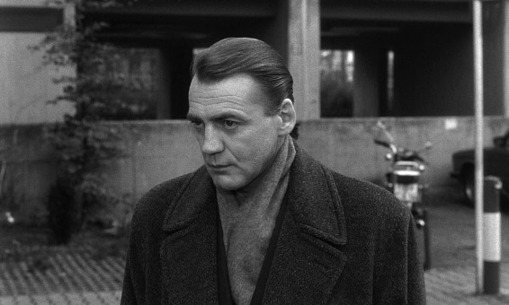
The Loose Cannon | Shaft – Shaft  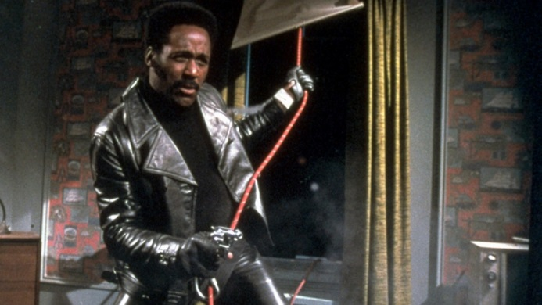 | John McClane – Die Hard  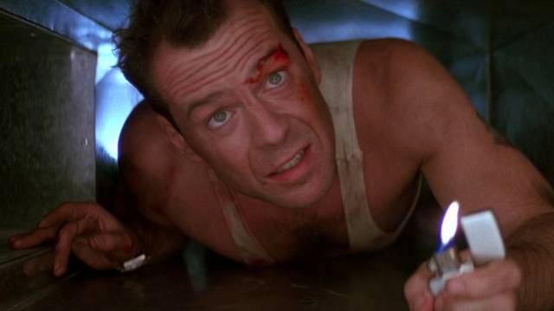 | Alex Foley – Beverly Hills Cop  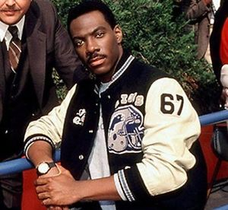
The  Obstructive  Bureaucrat | Usher – Spider Man 2  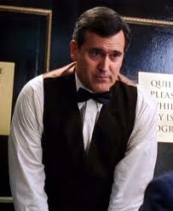 | Galloway – Transformers  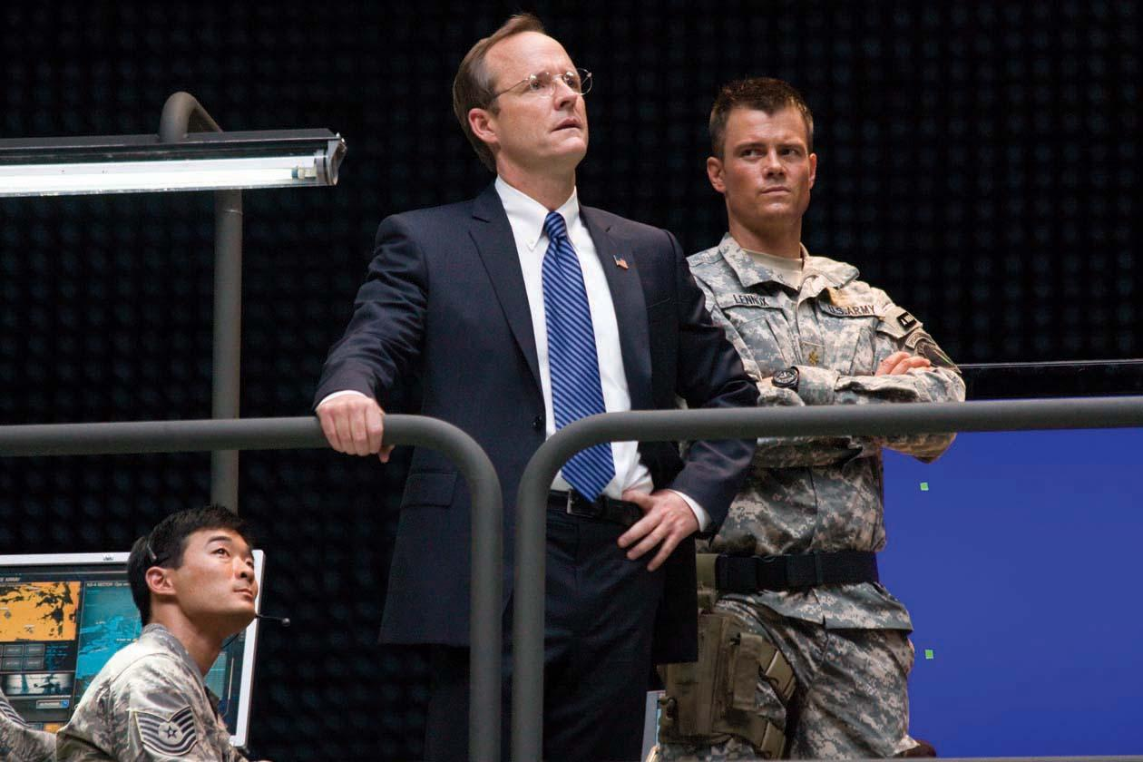 | Albert Nimziki – Independence Day  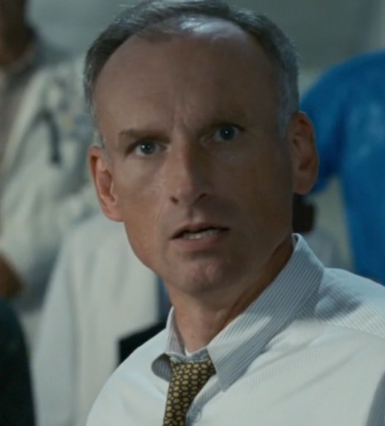
Advocate | Frank Galvin - The Verdict  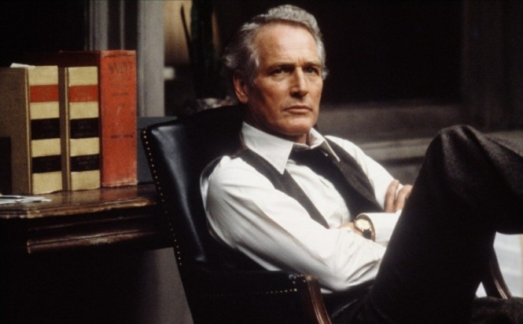 | Tom Hagen – The Godfather  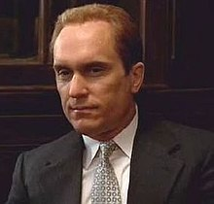 | Henry Drummond – Inherit the Wind  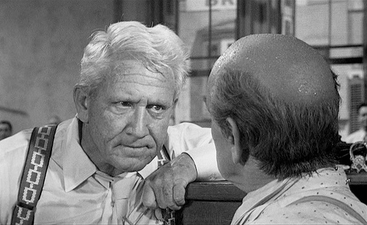
Addict | Mark Renton – Trainspotting  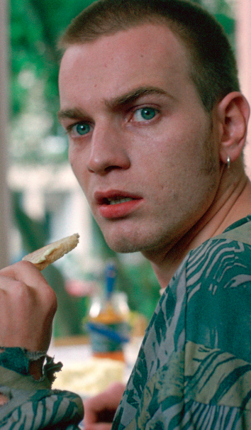 | Dominick DiNapoli – Fatso  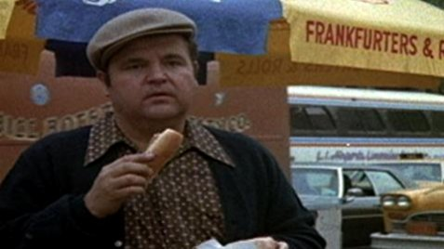 | Tony Montana – Scarface  